RMIT UNIVERSITY

School of Engineering

OENG1206 – Digital Fundamentals

Practical Task 1

Introduction to MATLAB

Lecturer: Katrina Neville

Practical tutor: Breyner Andres Castro

Student Names: Morrison Van Student Numbers: s3944443

Student Names: PanQing Xiao Student Numbers: s3654119

Group: PRA01/60 – Wednesday 14:30-16:30

Submission Due Date: 1st April 23:59

**Statement of Contribution**

|  |  |  |
| --- | --- | --- |
| **Student Name** | **Student Number** | **Contributions** |
| Morrison Van | s3944443 | MATLAB Script & this Word docx |
| PanQing Xiao | s3654119 | Word docx & MATLAB calculations before being transferred to another group. |

**Part 1: The physics of projectile motion**

**Task 1 – State the problem**

Evel Knievel’s aspiration was to motorcycle jump over the Grand Canyon however it never happened. This task explores the usage of mathematical formulas and computational programming to create a program to calculate and output data through the use of

$d=\frac{v0^{2}}{g}sin(2*{θ)}$. **We will work out the relationship between distance travelled (d) with initial velocity (v0) and angle of launch (a) by finding how fast Evel Knievel needs to travel.** Factors such as air resistance and changes to center of gravity are ignored.

**Task 2 – Specify your input and output data**

The input data based from $d=\frac{v0^{2}}{g}sin(2*{θ)}$ will be:

d = *183m* | displacement in meters as our input data

g = *9.8 m/s-2* | the acceleration due to gravity m/s-2 and is our constant input data

a = *pi/4* | the angle of launch (radian angle in radius) as our input data.

V0 = the initial velocity as our output in m/s  
The program can output the initial velocity to be able to cross the Grand Canyon however it cannot calculate anything further than that.

Assumptions are that the output data graph will appear parabolic to check the solution. Ignoring air resistance and center of gravity adjusts the results heavily as it is known these factors may lead to a much shorter distance covered than calculated.

**Task 3 – Calculate the Simple Physics for the Scenario**

Calculate the **initial velocity** required to jump over the Grand Canyon at its narrowest point.

$$d=\frac{v0^{2}}{g}sin(2*{θ)}$$

$$\sqrt{\frac{d}{\sin{2θ}}*g}=v0$$

$$v0=42.35 m/s$$

$$vkmph=42.35*3.6=152.45 km/h$$

**Task 4 – Use MATLAB to Find Velocity**

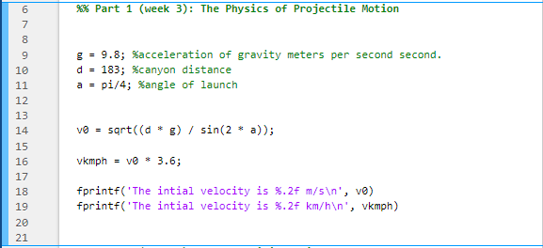

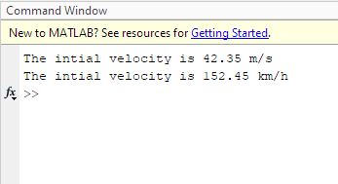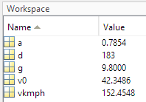

Hand calculations and MATLAB appears to have the same results with km/h velocity being *152.45km/h* and m/s velocity being *42.35m/s*.

**Part 2: Change Initial Height**

**Task 5 – State the problem and Determine the Input/Output**

The motorcycle jump now has an additional term, *H*, which changes the x-axis displacement due to the inclusion of an initial height. To be able to create the model and plot datapoints on a graph, using the $x=v0*t*\cos{θ}$ and $y=H+v0*t* \sin{θ}-\frac{1}{2}*g*t^{2}$, we must find *t* which is **time** in seconds and *H* is **initial height** in meters. In addition to finding the required **initial height** required to cross the Grand Canyon with an **angle of launch** of **45 DEGREES,** and **initial velocity** being **maximum 125km/h,** we have to find displacements achieved with 35, 45, 55 degrees angle of launch, plotted and presenting the angle which results in the greatest distance being achieved.

The input / output data are taken from the formulas $x=v0*t*\cos{θ}$ and $y=H+v0*t* \sin{θ}-\frac{1}{2}*g*t^{2}$ where:

**INPUT:**

y = 0m | displacement heigh in meters. y displacement does not change at initial height.  
g = 9.81 m/s-2 | acceleration due to gravity  
d = x = 183m | displacement of the Canyon in meters.   
a = 45 | angle of launch at 45 degrees. Then after that will be 35 and 55.  
t_all = 0:0.1:9 | time range from 0 to 9 seconds.  
v0 = 125/3.6 = 34.7222 | which is the initial velocity, converted to m/s-1.

**OUTPUT:**

t = time needed to cross the Grand Canyon and to solve for H.  
H = initial height needed to cross the Grand Canyon.  
To plot a graph to show launch angles of 35, 45 and 55 degrees, presenting the results of the greatest distance being achieved.   
The program can fulfill the tasks up to its scope, meaning it is able to calculate all points from 0-9 seconds however only with angles 35, 45 and 55 and no more than 9 seconds,

Assumptions are that 55 DEGREES will have the shortest displacements, the initial height displacement is 0 and time can be gained from calculating x-displacement as 183 meters, the distance to cross the Grand Canyon.

**Task 6 – Calculate the Physics for the new Scenarios**

To calculate **time (t)** taken to cross the Grand Canyon using initial velocity and angle.

$$x=v0*t*\cos{θ}$$

$$183 meters=v0*t*\cos{θ}$$

$$\frac{183 meters}{v0* \cos{θ}}=t$$

$$\frac{183 meters}{\frac{125}{3.6}* \cos{(\frac{π}{4})}}=t$$

$$t=7.45 seconds$$

Calculate **initial height (H)** using **time (t)** to cross the Grand Canyon.

$$y=H+v0*t* \sin{θ}-\frac{1}{2}*g*t^{2}$$

$$0=H+\frac{125}{3.6}*7.45* sin({\frac{π}{4})}-\frac{1}{2}*9.81*{7.45}^{2}$$

$$H=y-v0*t* \sin{θ}+\frac{1}{2}*g*t^{2}$$

$$H=0-\frac{125}{3.6}*7.45* \sin{(\frac{π}{4}})+\frac{1}{2}*9.81*{7.45}^{2}$$

$$H=89.49 meters$$

Calculating **x-displacement** by adjusting **angle of launch (a)**.

**35 DEGREES:**

$$y=H+v0*t* \sin{θ}-\frac{1}{2}*g*t^{2}$$

$$0 =89.49+\frac{125}{3.6}*t* \sin\left(35\right)-\frac{1}{2}*9.81*t^{2}$$

$$4.905t^{2}-19.92t=89.49$$

$$t=6.76 seconds$$

$$x=v0*t*cos⁡θ$$

$$x=\frac{125}{3.6}*6.76*cos⁡(35)$$

$$x=192.28 meters$$

**55 DEGREES:**

$$y=H+v0*t* \sin{θ}-\frac{1}{2}*g*t^{2}$$

$$0=89.49+\frac{125}{3.6}*t* \sin\left(55\right)-\frac{1}{2}*9.81*t^{2}$$

$$4.905t^{2}-28.44t=89.49$$

$$t=8.06 seconds$$

$$x=v0*t*cos⁡θ$$

$$x=\frac{125}{3.6}*8.06*cos⁡(55)$$

$$x=160.55 meters$$

From our results, we can see that adjusting the **angle of attack (a)** to **35 DEGREES,** it has the longest **x-dispalcement** of **192 meters**. Adjusting to **45 DEGREES** comes with **183 meters** and the last in place would be the **55 DEGREES** with **161 meters.** The angle of **35 DEGREES** satifies the condition to cross the Grand Canyon however the **55 DEGREES** does not.

**Task 7 – Use MATLAB to Solve Problem and Test Program** 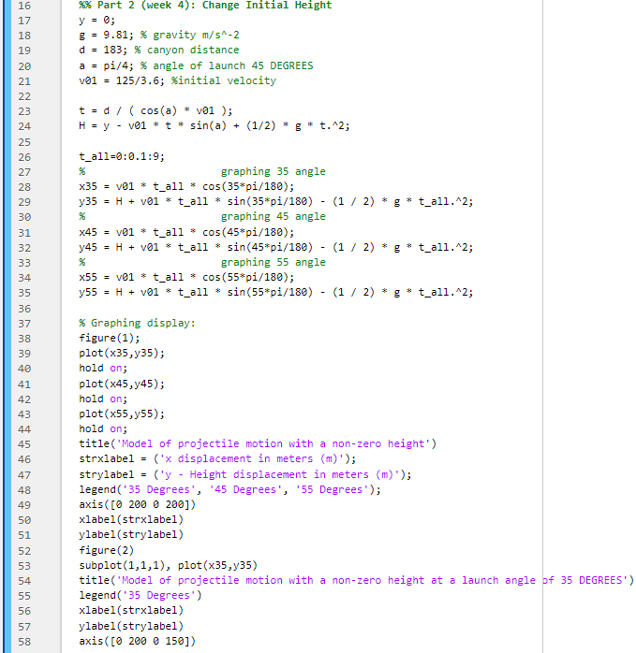

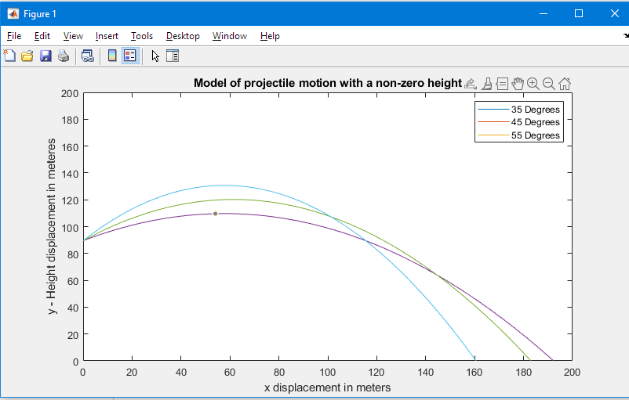

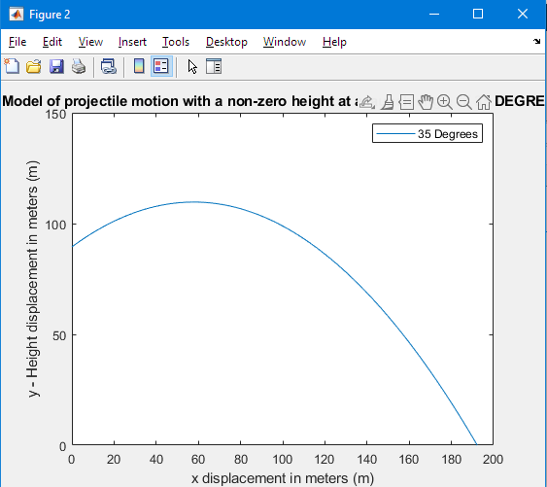

**MATLAB CODE:**

%% PRACTICAL EXERCISE 1: Introduction to MATLAB

clear, clc

%% Part 1 (week 3): The Physics of Projectile Motion

g = 9.8; %acceleration of gravity meters per second second.

d = 183; %canyon distance

a = pi/4; %angle of launch

v0 = sqrt((d * g) / sin(2 * a));

vkmph = v0 * 3.6;

fprintf('The intial velocity is %.2f m/s\n', v0)

fprintf('The intial velocity is %.2f km/h\n', vkmph)

%% Part 2 (week 4): Change Initial Height

y = 0;

g = 9.81; % gravity m/s^-2

d = 183; % canyon distance

a = pi/4; % angle of launch 45 DEGREES

v01 = 125/3.6; %initial velocity

t = d / ( cos(a) * v01 );

H = y - v01 * t * sin(a) + (1/2) * g * t.^2;

t_all=0:0.1:9;

% graphing 35 angle

x35 = v01 * t_all * cos(35*pi/180);

y35 = H + v01 * t_all * sin(35*pi/180) - (1 / 2) * g * t_all.^2;

% graphing 45 angle

x45 = v01 * t_all * cos(45*pi/180);

y45 = H + v01 * t_all * sin(45*pi/180) - (1 / 2) * g * t_all.^2;

% graphing 55 angle

x55 = v01 * t_all * cos(55*pi/180);

y55 = H + v01 * t_all * sin(55*pi/180) - (1 / 2) * g * t_all.^2;

% Graphing display:

figure(1);

plot(x35,y35);

hold on;

plot(x45,y45);

hold on;

plot(x55,y55);

hold on;

title('Model of projectile motion with a non-zero height')

strxlabel = ('x displacement in meters (m)');

strylabel = ('y - Height displacement in meters (m)');

legend('35 Degrees', '45 Degrees', '55 Degrees');

axis([0 200 0 200])

xlabel(strxlabel)

ylabel(strylabel)

figure(2)

subplot(1,1,1), plot(x35,y35)

title('Model of projectile motion with a non-zero height at a launch angle of 35 DEGREES')

legend('35 Degrees')

xlabel(strxlabel)

ylabel(strylabel)

axis([0 200 0 150])